

Pay By Scan
Vendor Playbook
Version 1.2

Contents
0.0 Purpose 3
0.1 Purpose Of playbook 3
1.0 Overview 3
1.1 Business Overview? 3
1.2 What’s the Objective for Home Depot with Pay by Scan? 3
1.3 What are the Benefits of Pay By Scan? 3
1.4 What is the Potential Impact of PBS? 3
2.0 Assessment 3
2.1 How to check if a Vendor can be Converted to Pay By Scan : 3
2.2 Vendor EDI Requirements: 3
3.0 Required Documentation 5
3.1 Supplier Buying Agreement (SBA): 5
3.2 Pay By Scan Vendor Addendum: 5
3.3 Vendor and 3rd Party Inventory 6
4.0 Vendor Reconciliation (Payment) 6
4.1 852 Sales Document 6
4.2 820 Sales Document 6
4.3 PBS File Extract 7
4.4 PBS File Extract and EDI 820 Reconciliation 7
5.0 Store Operations 8
5.1 Inventory Management 9
6.0 Tools for PBS 11
6.1 POS Flat File Layout 11
Record: DTL – Transactions (Sales/Returns) Record Format 12
Record: DTL – Tax Record Format 13
6.2 Inventory Management Template: 14
Appendix A: SBA Change Form 15
Appendix B: PBS Addendum 17

Purpose

Purpose Of playbook
The Purpose of the Pay By Scan Playbook is to enable Vendor to effectively convert regular articles to Pay By Scan and Operate the program efficiently.

Overview

Business Overview?
Pay By Scan (PBS) is a Vendor Managed inventory program where the vendor owns the inventory until the product is purchased by the customer and is scanned through the POS. Pay By Scan is designed for Retailers and Vendors to efficiently and effectively manage high consumption merchandise.

What’s the Objective for Home Depot with Pay by Scan?
- The PBS program allows the Vendor to better serve customers by improving the quality and in-stock condition of product while reducing the exposure to Shrink

What are the Benefits of Pay By Scan?
- No RTV’s, write off’s or physical receiving required
- Pay By Scan has the potential to increase sales (industry benchmarking has shown an increase of 4 to 20%)

What is the Potential Impact of PBS?
- There are no purchase orders with Pay By Scan
- There are no physical inventory on hands (article look up will not display any on hand details)

Assessment

How to check if a Vendor can be Converted to Pay By Scan :
The Vendor will need meet the following criteria to ensure that they can manage the Pay By Scan process:
- IT requirements (EDI 820 Remittance Advice, 852 Sales and PBS Extract articles sales by store)
- Good financial standing with Home Depot (any Debt balance)
- Well developed field service capabilities (strong field rep team)
- Strong market focus and in tune with market selling seasons

Vendor EDI Requirements:
Electronic Data Interchange (EDI) is an exchange of business transactions utilizing a standard format. It is Home Depot’s preferred method for electronic exchanges of business transactions. The Home Depot EDI program relies on the standards and conventions as developed by the American National Standards Institute (ANSI) that are common across the industry and used by most major retailers.
Details can be found at Supplier Centre, EDI Suppliers Training Manual and Electronic Exchange
Checklist for a Vendor to be on PBS:
- Vendor's EDI connection method must be through a Value Added Network (VAN)
- Vendor must be able to support EDI 820
- Vendor must be able to process PBS File Extract
- Vendor must be able to receive PBS File Extract via FTP (File Transfer Protocol)
EDI point of contacts
  - On-boarding Support: B2B_testing@homedepot.com
  - Production Support: b2b_production_support@homedepot.com
  - Phone: 770-433-8211 ext 10036

Information to be provided to the Vendor by the Merchant:
- PBS File extract specification (6.1 Tools POS Flat File Layout)
- PBS File extract sample (6.1 Tools Flat file and as shown in Figure 1)
- PBS File extract and EDI 820 Reconciliation Process
- Sample EDI 820
- EDI Points of contact

Steps to enable Vendor to establish VAN
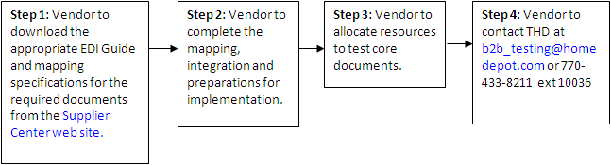
Figure 1: PBS File Extract Sample

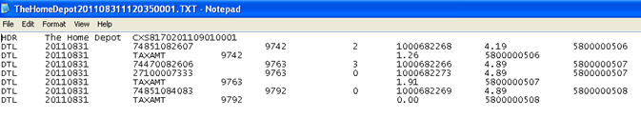

Required Documentation

Supplier Buying Agreement (SBA):
The terms and conditions of the SBA will need to be reviewed with the Vendor by the Merchant. The following are the changes to the SBA to support PBS:
- Payment terms should be Net 10 or 15 days (as payment will be based solely on POS). There should be no applied discount to the terms.
- Vendor should be set as Prepaid as there are no purchase orders to be managed through the cross dock on collect vendors (vendors are solely responsible for shipping product to a store)
If it’s an existing vendor, use an SBA change form (Appendix A: SBA Change Form) to make the necessary changes to ensure the payment terms and freight are set correctly.
Figure 4 – Sample SBA Change Form
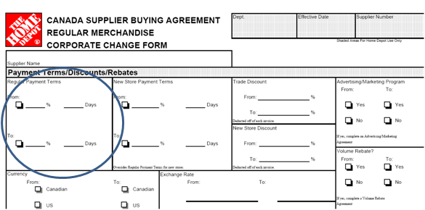

Pay By Scan Vendor Addendum:
In addition to the SBA form, the vendor is required to sign an Addendum to the SBA (Appendix B: PBS Addendum) The addendum states:
- The vendor will hold the title of the merchandise until it is sold through POS
- Home Depot will provide electronic reporting of the previous day sales
Figure 5 – Addendum Sample

Vendor and 3rd Party Inventory
If there is existing inventory of articles that are converting to Pay By Scan, it is the vendor’s responsibility to work with a 3rd party to provide inventory counts at each store on each article. The vendor will be required to provide a schedule of the inventory count dates by Market by store. Vendor Cost Conditions and Discounts (Volume Rebate)
Sales for PBS articles will be captured in a separate program that will record the total dollar amount of the PBS articles sold at the info record cost of the article.
The total amount at cost will be added to the rebate agreement for collection purposes.
At the end of the month we will collect the earned rebate amount.,

Vendor Reconciliation (Payment)
There are 3 documents the vendor will receive once on PBS 852 Sales Document, 820 Sales Document and PBS File Extract:

852 Sales Document
  - Contains daily sales data (PBS and non-PBS).
  - Should be used by vendor for sales information
  - Should not be used for payment reconciliation

820 Sales Document
  - Vendors marked to receive EDI Remittance Advice (by checking the Pmt adv by EDI field on the Company Code – Accounting view) will receive their remittance advice electronically when the electronic payment program (F110) is executed to remit directly to a vendor’s bank account.
  - SAP generates an Outbound IDOC (PEXR2002) and an EDI message 820 (Message type: REMADV) is sent directly to the vendor through the B2B layer.
  - Document frequency will remain as per Vendor’s master data (payment terms)
  - Invoice # in the 820 will be tied back to the PBS File Extract for reconciliation purposes

PBS File Extract
  - Will be sent to Vendor when payment is invoice is generated by THD.
  - Summarizes sales by site and article.
  - Summarizes taxes for each invoice
  - Will contain system generated Reference # every time an invoice is generated by PBS consignment settlement program.
  - Invoice Number is at the document level.
  - Invoice number in the PBS File Extract will be tied back to the 820 for reconciliation purposes.

PBS File Extract and EDI 820 Reconciliation
The PBS file extract is sorted by Invoice number. The file extract program will read all the individual tax line items and add the tax item amounts to get the total tax amount for the given invoice.
The vendor will be paid based on the payment terms. The vendor will have to capture all the PBS file extracts generated on a daily basis and determine which invoice reconciles on the EDI 820. There is no way that The Home Depot can inform the vendor as to which EDI 820 remittance advice will contain which invoice #. The vendor will need to reconcile multiple PBS extracts with a single EDI 820.
In Order to reconcile the PBS Extract and the EDI 820 the vendor will require doing the following:

- Calculate the total cost of goods sold per record, by multiplying the quantity by the unit cost on each individual line item.
- Second, add the total amounts per record obtained from step 1, for all the records for a given reference#.
- Add the total tax amount for the given reference# to the total amount obtained from step 2.
Figure 6 – Reconciliation example
For example to reconcile the total amount being paid to the vendor on the EDI 820, review the PBS File extract, for reference# 5800000506, then the values obtained as a result of step 1 calculation would be:
2 x 4.19 = $8.38
Once the calculations for step 1 are completed, the total tax amount per record, can be calculated by adding the individual tax values, to get the step 2 amount, which would be: $1.26.
To calculate the final amount which is shown on the EDI 820, the vendor needs to add the total tax amount to the total amounts of each individual line items for the given on the reference#, to calculate the total amount for step 3, add the tax and total unit cost amounts i.e. $1.26 + $8.38 = $9.64.
The amount of $9.64 will be the value the vendor will see on the 820 for reconciliation with the PBS file extract, for the given reference#.
Similarly following the same logic for the remainder of the invoices on the inserted PBS file extract, we get the following values:
Invoice# 2: 5800000507
3 x $4.89 = $14.67
0 x $4.89 = $0
Total tax = $1.91
Total amount invoice amount on EDI 820 = $14.67 + $1.91 = $16.58
NOTE: If the ZTRD trade discount condition type is maintained for the vendor, then there will be a difference in the unit cost price pulled into the PBS file extract and the unit cost price which the system uses to calculate the amount on the invoice, i.e. reference#. In this case, the vendor will never be able to reconcile the PBS file extract to the 820.
Figure 7 – PBS Vendor Document Flow
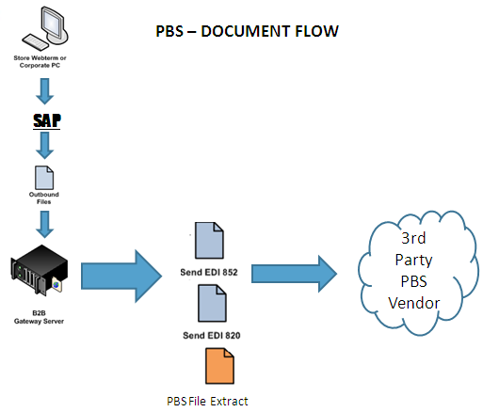

Store Operations
For the PBS program to be successful, Home Depot must fulfill its obligations under the program to assume as much responsibility as the suppliers when it comes to maintaining the merchandise and bays to ensure quality product is being offered to our customers at all times.
Store Responsibilities
- PBS merchandise will not be included in the physical inventory count.
- All merchandise is either received by the Supplier Representative (no purchase order to receive) or through common carrier (invoice only)
- Do not sign a bill of lading, delivery receipt, packing list, or any other documentation for VMI/PBS product, unless shipped from the common carrier.
- Maintain the set integrity of store layout as determined by the Home Depot.
- Clean and maintain fixtures, displays, signage, and price labels.
- Report Supplier non-compliance to the Store Manager and the District Operations Manager.
- Follow all standard Asset Protection merchandising and storage guidelines.
Goods Movements / Store Transactions:
PBS merchandise will be restricted from system transactions disallowing the movement of goods. This system limitation is in place as Home Depot does not own the merchandise (no purchase orders in the system).
Store facing My Store Tools portal applications will identify PBS merchandise clearly to Store Associates as well as prompt system error messages informing them that a PBS article transaction is disallowed in the

- No POS Markdowns or Write-Offs on PBS merchandise are allowed.
- No charitable donations of PBS product are allowed.
- No store use of PBS product is allowed.
- No store to store transfers are allowed on PBS product, unless it is from the vendor.
- Do not process RTVs for PBS inventory.
- Handle Will Calls and Deliveries the same as regular merchandise.
- Return Policy - Process the customer’s return. Send salable product to the sales floor. Place all non-salable products in a designated location for the vendor to review and discard.
- Do not discard or cull PBS merchandise that is on the sales floor, since Home Depot does not own the product (Suppliers will cull and destroy their own product)
- Prior to the vendor discarding the product, stores must review and verify that all merchandise is PBS
Vendor Responsibility:
- Ensure that stores contain adequate inventories of products.
- Stores should be serviced during store operating hours.
- Provide new store set-ups as requested by Home Depot.
- Provide product knowledge training to associates upon request.
- Adjust frequency of store visits depending on sales velocity.
- Provide a dedicated merchandising team to service PBS products in the appropriate stores based on store sales volume and carrying capacity.
- Deliver products to stores and stock products on the retail floor promptly after the orders are received.
- Cull product on a consistent basis (involves removing non-salable product and replacing with salable product.

Inventory Management
Inventory levels can be monitored by leveraging detailed delivery information provided by the Vendor. Depending on the flow plan of the inbound receipts i.e. one time vs. weekly deliveries, the Merchant/IPR will provide an overall forecast for the year/season. The vendor will provide detailed information of what was shipped into the store and what was removed from the store. With live goods vendors, weekly updates will be required detailing what was shipped during the prior week. Please use the template provided to track inventory and upload information into the main document managed by IPR. (6.2 Inventory Management Template:)
IPR will monitor the inventory flow versus sales plans and purchase forecasts. If there are instances where sales plan is not being met, the Merchant will review the inventory levels with IPR and the Vendor to determine the root cause and resolution.

.

Tools for PBS

POS Flat File Layout
This document was developed to give assistance in creating the POS Flat File that will be extracted and transmitted to reflect Pay By Scan activity
- To prevent overwriting existing data, the filename of each file should be unique. Use the following format to ensure proper document recognition and integrity. File name will be named TheHomeDepotYYYYMMDDnnnn.POS where nnnn is a unique id or counter
Record Structure:
- Tab Delimited Flat File
- Multiple transaction documents per file possible
- At least two records are required for each Transaction; 1 Header and 1 or more Detail
- Column headers will not be provided
Record: HDR – Header Record
Loop: Max Use: 1 Usage: MANDATORY
PURPOSE: To start and identify the beginning of a POS File.
*Contact EDI group for assigned value

Record: DTL – Transactions (Sales/Returns) Record Format
loop: Min Use: 1 Usage: MANDATORY

PURPOSE: To start and identify the detail information of a POS File.

Record: DTL – Tax Record Format
Loop: Min Use: 1 Usage: MANDATORY
PURPOSE: To start and identify the detail tax information of a POS File.
For each invoice, the PBS file extract will contain at least two records, one transaction record and one tax record. The tax record will always follow the transaction record in the PBS file extract.

Inventory Management Template:
The following template is what the vendors will provide following any shipment into Home Depot. The process should be outlined with vendor prior conversion of PBS.
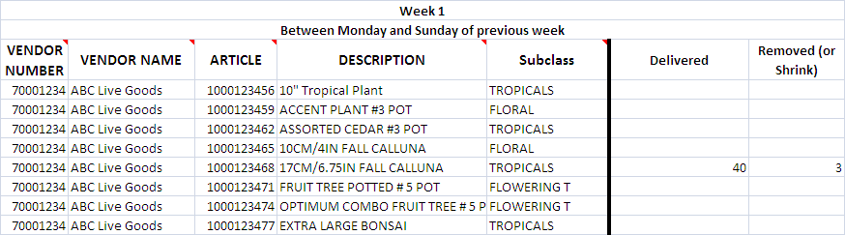

Appendix A: SBA Change Form

Appendix B: PBS Addendum

